**If we need to build new/scratch site:**

* First meeting with designer/developer
* Designer/developer should have to ask their question. Like which font-style, color, xd/figma, functionally, server setup que etc.
* Strongly follow teamwork to add each and every task in it
* Our custom theme (with proper structure like css folder, js folder, image folder, font folder, template folder)
* Home page
* About us page
* Contact us page
  + Enquiry form (Name - required, Email - required, Message, checkbox - required - We will never share your data with third parties for marketing purposes. See our privacy policy link to privacy policy page)
  + Address, Email, Phone number, Timing detail ()
  + Google Map
* Privacy policy page
* Add dummy 6 post with proper title, dummy description, feature image
* Create header menu and footer menu - from appearance menu
* Delete one default comment also change setting so nobody can comment on site from menu settings -> Discussion
* Default permalink is “Post name”, that setting available at settings -> Permalink

If woocommerce site :

* Front :
  + Product list page
  + Product category page
  + Product detail page
  + Cart page
  + Mini cart at header menu
  + Checkout page
  + After place order, thank you page
  + Login, Registration, Forget password
  + My account and its inner pages, like order list, edit profile, address edit etc
* Backend :
  + Configure default whole woocommerce setup
  + Add dummy product with proper title, dummy content, feature image, product gallery, short description, price, category
  + Create proper category
  + Any email’s color combination should be match to logo

**Plugins:** Base on client/site requirement:

* ACF Pro
* Elementor, Elementor Pro
* Rank match SEO
* WPML (if site is in Multilanguage)
* Remove default plugin like : Akismet Anti-Spam, Hello Dolly

---------------------------------------------------------------------------------------------------------------------------------

**# Backend:**

* Domain URL always with “S” https://
* Theme name and author name, description should be proper
* Theme screenshot : It should be always whole Homepage screenshot
* All post, page, template name's first letter always capital and there should not any special characters like underscore etc.
* Underscore should not be there in menu name (appearance -> menus)
* Give proper name to image and then upload/use
* About Dummy text :

Dummy text should always be below one: lorem ipsum

<https://www.lipsum.com/>

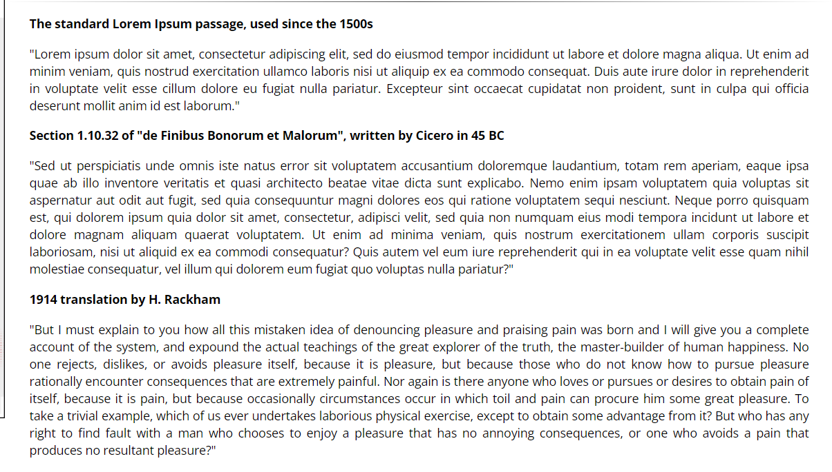

* Check every plugin, WordPress, theme should be in latest version (ACF Pro)
* Use default WordPress editor, not classic editor
* Hide revision from all pages
* Visitor should not comment without login
* Tagline and title should be proper | settings -> general
* Dropdown fields should have first entry as blank or text like ‘Select’ and should work proper functionally
* Email should be connect with “mailto:” and mobile/telephone number should be connect with “tel:”
* If we create any shortcode, give proper name to it
* For any code, please give proper comment, url etc so other developer can understand easily
* Never use full URL in code either it is php file or js file
* Elementor, normal editor, wysiwyg editor or any other editor's default functionality should never to stop by our css/code, Like Bold, Italic, link, bullet, H tag etc

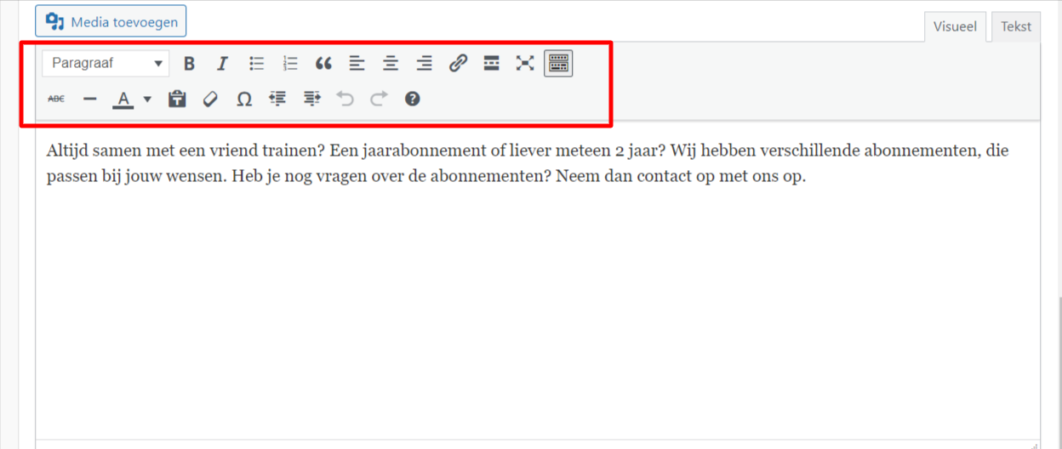

* Any deactivated/unwanted plugin should not there
* Remove unwanted themes (Keep 1 extra theme)
* Remove unwanted pages or page which are already in trash
* Remove unwanted post or pages which are already in trash
* Delete trash item permanently
* After create test user, need to remove it
* After test any enquiry form, need to remove it
* Delete unwanted php, css, js files from theme
* If we have taken backup using Updraft plugin, than after download in local, delete those source from server and also delete this plugin
* Solve console error
* Sitemap always there
* Check Robot file always there

User-agent: *

Disallow: /wp-admin/

Allow: /wp-admin/admin-ajax.php

Sitemap: URL of sitemap here

* GDPR, cookie

Welcome! This site requires cookies and various 3rd party services to function properly. To continue using the website you must consent to our Privacy & Cookie Policy. Please accept to agree

Button : Cookie Settings

Button : ACCEPT

CookieYes | GDPR Cookie Consent & Compliance Notice (CCPA Ready)

https://wordpress.org/plugins/cookie-law-info/



**# Frontend:**

* Favicon should be there (.ico 16*16, 512*512, 64*64)
* Logo/icon should be in SVG.
* Logo should be clickable and redirects to the Home page
* Header menu
* 3rd party url, social media link always open in new tab
* Social icon should not be visible after removing link from backend
* If we don't know actual link/url on button, menu or any other place, just use/set link/url with “javascript:void(0)” not with “#”
* 404 page search field should have “search” texbox and button
* In every image tag, there should be “alt” tag with image name
* If suppose we remove image from backend, one default image Backend
* Need to check functionality, what is added by ACF field, like to remove some fields and check front, to add more fields etc.
* Full url should be not there on button (elementor)
* Empty tag should not be there
* Image should never blur
* Video should be play automatically(except client requirement different)
* Arrow button on slider should be properly clickable and viewable
* If there was not featured image set on backend, than show default image
* **Contact form / Enquiry Form testing :** 
  + For required field, there should be star with placeholder
  + Error message color Red. Success message color should be green
  + When submitting a form, its entry should be in the backend.
  + Email Format :
    - 2 Email Notification : 1 Admin, 2 visitor (who has fill the form and add their own email address)

**Admin Email:**

**Sub:**

Website name : Enquiry

For ex :

Exie : Enquiry

**Body:**

Hello Admin,

We're getting below enquiry details :

Name : ABC

Email : [abc@gmail.com](mailto:abc@gmail.com) (Should be with ‘mailto’)

Message : lorem ipsum

-

Thanks,

Exie Team

**Visitor Email:**

**Sub:**

Website name :: Enquiry

For ex :

Exie :: Enquiry

**Body:**

Hello ABC,

Thank you for contacting us. We will contact you soon.

We're getting below enquiry details from you :

Name : ABC

Email : [abc@gmail.com](mailto:abc@gmail.com) (Should be with ‘mailto’)

Message : lorem ipsum

-

Thanks,

Exie Team

**# Most need to take care by designer:**

* Whole site have single font-style
* Whole site have same color, even if xd designer have given it different (except actual client require)
* Logo should be clickable and redirects to the Home page
* Give proper name to image and then upload/use
* One page must have only 1 - H1
* Elementor, normal editor, wysiwyg editor or any other editor's default functionality should never to stop by our css/code, Like Bold, Italic, link, bullet, H tag etc



* Button color issue : like when we click on any button, it was change it BG color (same as what we have set on hover of it), but after click, it should come in their original color
* Slider or banner image should be like to fit in one screen
* Also if there will be text on slider/banner it should be fit on responsive (we should decrease font-size base on screen size : mobile, Ipad, Desktop)
* Every section should have same/equal space to top-bottom
* Every button should have same BG color, same hover effect, style
* Image should never blur
* Image/design should looks proper for all screen resolution
* Video should be play automatically(except client requirement different)
* Arrow button on slider should be properly clickable and viewable
* Images should be in .PNG when export from figma
* Check Image size issues, image name, tool tip text etc.
* Responsive should be checked for all sites (Test in mobile device, Iphone)
* In responsive menu should always work
* In responsive, never get horizontal scroll
* Check site in Chrome, FF, Safari
* Test with different screen resolutions like from big desktop to small mobile etc.
* Test with different Android IOS devices.

-------------------------------------------------------------------------------------------------------------------------------------

**Create Documentation:**

* Always create with backend, frontend url & backend, frontend screenshot
  + With Credential
  + Header
  + Footer
  + Pages
  + All page URL/Link

------------------------------------------------------------------------------------------------------------------------------------

**Before making live:**

* Check every plugin, WordPress, theme should be in latest version (ACF Pro)
* Any deactivated/unwanted plugin should not there
* Remove unwanted theme
* Remove unwanted pages or page which are already in trash
* Remove unwanted post or pages which are already in trash
* Delete trash item permanently
* Remove unwanted themes (Keep 1 extra theme)
* Delete unwanted php, css, js files from theme
* If we have taken backup using Updraft plugin, than after download in local, delete those source from server and also delete this plugin

**When we making site live:**

* Get and check proper all details like FTP, database detail
* Take current live site backup using updraft
* Ask NT to download require source from our server
* Temporary of live Domain required, put page like 'Site under maintenance'
* Upload your source, and import database
* Domain URL always with SSL : https://
* Change/set database detail in config file
* Login in backend and save permalink first
* Install “Better search and replace” plugin and change URL
* Again save permalink
* Reconnect elementor plugin

**After make site live:**

* All page/url should be work on live url, it should not go on old dev site
* Test enquiry form, and after test set client email address and also delete tested entry from backend
* If woocommerce, check every page with functionality like product list with sort by dropdown and filter, add to cart, cart page, checkout, place order, check order email, backend entry
* Mobile check menu and all over site once, like major functionality should not be break
* Sitemap always there
* Check Robot file always there
  + User-agent: *
  + Disallow: /wp-admin/
  + Disallow: /wp-includes/
* Google analytics code, google tag manager code should there - if client have provide

==================================================================================

**QA List:**

<https://docs.google.com/document/d/1zZPMWvwCAEUwcr8E_SoiYHybftb0iGySiJ3QgCTFQLo/edit#>

==================================================================================

**For speed:**

* Take backup of theme and database
* Take screenshot of gtmetrix, google pingdom, google speed
* Update every plugin
* Update every theme
* Update WordPress
* Solve console error
* If require set some gzip, cache expire code in htaccess
* Take screenshot of gtmetrix, google pingdom, google speed

**General:**

* You should have your own proper sheet/doc from where you get all project related details (Don't use Google drive DOC or sheet)
* Always keep practice to write down task, discussion points in notebook OR notepad what I directly discuss with you orally
* For project related discussion, always keep communication in internal skype group
* You should have your own project and task list
* Write proper description, task detail when log hrs. (Never write like client suggested changes)
* Not use personal email, google drive etc
* Not require to send email at morning

**Leave:**

* 1 day leave, applied 1 day before
* 2 day leave, applied 2 day before
* And so on
* Early : just apply in first hrs when you come in office

**Activity before you leave office:**

* Keep 10-15 min before your leave time and give update in skype, email
* Give proper project wise update with URL, screenshot and task wise
* Write proper status if each task with its time in bracket
* Without forget, log hrs. in teamwork

**Formats:**

**At morning, work schedule format:**

# Project name : ABC [Total time to work on this project]

- Task/Point description (Approx. time require)

- Task/Point description (Approx. time require)

- Task/Point description (Approx. time require)

and so on...

# Project name : XYZ [Total time to work on this project]

- Task/Point description (Approx. time require)

- Task/Point description (Approx. time require)

- Task/Point description (Approx. time require)

and so on...

**At evening, work update format :**

# Project name : ABC [Total spent time on this project]

- Task/Point description (Status like : Done / In progress)

- Task/Point description (Status like : Done / In progress)

- Task/Point description (Status like : Done / In progress)

and so on...

# Project name : XYZ [Total spent time on this project]

- Task/Point description (Status like : Done / In progress)

- Task/Point description (Status like : Done / In progress)

- Task/Point description (Status like : Done / In progress)

and so on...

============================================================================

**Below are for example/reference, work schedule format at morning:**

# Project name : Guitar-Village [5 hrs.]

- I'll create 2 field (blog author name and banner images) using ACF for blog detail page [2 hrs]

- I'll add all the blogs. [2 hrs.]

- I'll design product detail page URL : <https://wordpress-627397-2183775.cloudwaysapps.com/product/music-man-sterling-majesty-pearl-white> [1 hrs]

# Project name : Spacetocreate [4 hrs.]

- I'll add some sections like, event, blog at space detail page. [2 hrs.]

- I'll create an order history page [2 hrs.]

**Below are for example/reference, work update format at evening:**

**# Project name : Guitar-Village [5 hrs.]**

- I've create 2 field (blog author name and banner images) using ACF for blog detail page [Done]

ACF url : <https://wordpress-627397-2183775.cloudwaysapps.com/wp-admin/post.php?post=6915&action=edit>

For example backend url : <https://wordpress-627397-2183775.cloudwaysapps.com/gibson-custom-murphy-lab/>

Front url : <https://wordpress-627397-2183775.cloudwaysapps.com/wp-admin/post.php?post=78&action=edit>

image.png

image.png

image.png

- I've added all the blogs. [Done]

Back-end URL : [https://wordpress-627Related screenshot/images here397-2183775.cloudwaysapps.com/wp-admin/post.php?post=7112&action=edit](https://wordpress-627397-2183775.cloudwaysapps.com/wp-admin/post.php?post=7112&action=edit)

Front-end URL : <https://wordpress-627397-2183775.cloudwaysapps.com/blog>

image.png

image.png

- I've design product detail page URL : <https://wordpress-627397-2183775.cloudwaysapps.com/product/music-man-sterling-majesty-pearl-white> [In progress]

image.png

**# Project name : Spacetocreate [4 hrs]**

- I've added some sections like, event, blog at space detail page. [Done]

For ex back-end URL : <https://devcf7web.websiteserverhost.com/spacetocreate/wp-admin/post.php?post=11570&action=edit>

Front-end url : <https://devcf7web.websiteserverhost.com/spacetocreate/space/wolvecamp-lounge/>

image.png

image.png

image.png

- Create order history page [Done]

Back-end URL : <https://devcf7web.websiteserverhost.com/spacetocreate/wp-admin/admin.php?page=space-order-list>

image.png

==============================================================================

**Base on above format:**

- First letter always capital

- As a prefix (Starting of point) : not add any other character like greater than sign (>>), hash (#), we can only use dash(-)

**The purpose of to follow this same format for all people are:**

- It can make our day to day process more faster, clean & easy to understand

- It will reduce our oral communication/confusion about task

- We all can quickly check status of each task/points

- If we add some url/screenshot, so client can quickly and easily understand what we have work

- Task/points will be look more attractive, instead of messy/mix

- If we follow same format than daily base we not need to remember, like what/how I've given work update at yesterday in term of format

- It will be also easy for me/Hemangbhai to provide update to client, instead of to correct format of each people, spelling mistake etc

===============================================================

**Plugins List**

**Free cookie plugin :**

CookieYes | GDPR Cookie Consent & Compliance Notice (CCPA Ready)

https://wordpress.org/plugins/cookie-law-info/

WPS Hide Login

<https://wordpress.org/plugins/wps-hide-login/>

Widgets for Google Reviews

https://wordpress.org/plugins/wp-reviews-plugin-for-google/

<https://wordpress.org/plugins/rich-reviews/>

Maintenance

https://wordpress.org/plugins/site-offline/

https://wordpress.org/plugins/maintenance/

Rank Math SEO

https://de.wordpress.org/plugins/seo-by-rank-math/

Better search and replace

https://wordpress.org/plugins/better-search-replace/

Contact Form 7

https://wordpress.org/plugins/contact-form-7/

MC4WP: Mailchimp for WordPress

https://wordpress.org/plugins/mailchimp-for-wp/

AddToAny Share Buttons

https://en-au.wordpress.org/plugins/add-to-any/

Prime Slider

https://wordpress.org/plugins/bdthemes-prime-slider-lite/

REDIRECTION

https://wordpress.org/plugins/redirect-redirection/

Paid cookie plugin :

https://borlabs.io/

UpdraftPlus WordPress Backup Plugin

https://de.wordpress.org/plugins/updraftplus/

Elementor Website Builder

https://de.wordpress.org/plugins/elementor/

Essential Addons for Elementor

https://en-za.wordpress.org/plugins/essential-addons-for-elementor-lite/

WooCommerce

https://wordpress.org/plugins/woocommerce/

Wordfence Security – Firewall, Malware Scan, and Login Security

https://wordpress.org/plugins/wordfence/

WP Mail SMTP

https://de.wordpress.org/plugins/wp-mail-smtp/

Jetpack – WP Security, Backup, Speed, & Growth

https://wordpress.org/plugins/jetpack/

WP Fastest Cache

https://wordpress.org/plugins/wp-fastest-cache/

Yoast Duplicate Post

https://de.wordpress.org/plugins/duplicate-post/

Limit Login Attempts Reloaded

https://en-au.wordpress.org/plugins/limit-login-attempts-reloaded/

The Events Calenda plugin

https://de.wordpress.org/plugins/the-events-calendar/

Newslater : MailPoet – emails and newsletters in WordPress

https://wordpress.org/plugins/mailpoet/

Admin Menu Editor Pro

http://adminmenueditor.com/

WP Activity Log

https://wordpress.org/plugins/wp-security-audit-log/

Really Simple SSL

https://en-gb.wordpress.org/plugins/really-simple-ssl/

User Role Editor

https://en-gb.wordpress.org/plugins/user-role-editor/

WPForms

https://wpforms.com/

ManageWP - Workers

https://de.wordpress.org/plugins/worker/

WPML :

https://wpml.org/

WooCommerce Multilingual & Multicurrency with WPML

https://wordpress.org/plugins/woocommerce-multilingual/

WooCommerce Load More Products

https://wordpress.org/plugins/load-more-products-for-woocommerce/?utm_source=free_plugin&utm_medium=plugins&utm_campaign=BeRocket_LMP

WP Activity Log for WooCommerce

https://wordpress.org/plugins/wp-activity-log-for-woocommerce/

LoftLoader

https://wordpress.org/plugins/loftloader/

Phoenix Media Rename

https://wordpress.org/plugins/phoenix-media-rename/

**Paid Plugin :**

SEOPress

https://wordpress.org/plugins/wp-seopress/

https://www.seopress.org/

Gravity Forms

https://gravityforms.com/

Facebook Feed Pro

https://smashballoon.com/custom-facebook-feed/

Instagram Feed Pro

https://smashballoon.com/instagram-feed/

B2BKing Core

https://wordpress.org/plugins/b2bking-wholesale-for-woocommerce/

https://codecanyon.net/item/b2bking-the-ultimate-woocommerce-b2b-plugin/26689576

Fancy Product Designer

https://codecanyon.net/item/fancy-product-designer-woocommercewordpress/6318393

**Thank You !!**